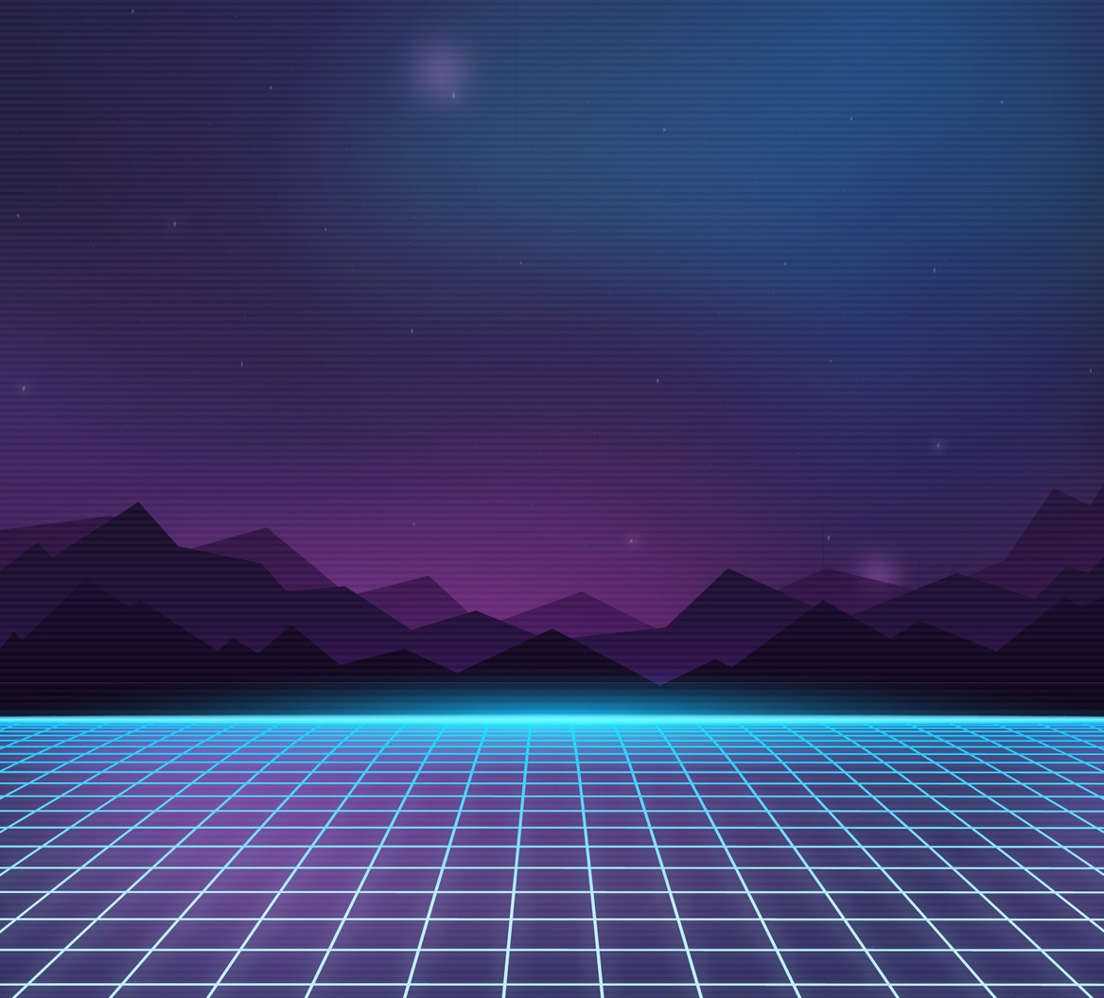

















Secondary

Game Design Document Template
Proudly supported by

A game design document is as important as the video game itself. It tells judges what you planned to do, the ideas behind the content of your game and how you solved problems. Your GDD also helps judges understand what you wanted to develop and the reasons why things might be different to your plan.
Sometimes things don’t go to plan, and that’s okay, explaining what happened and how you changed things is an important part of video game development.
Professional video game designers use GDDs to communicate their ideas and reflect on their work too.

Instructions
Try to answer all questions in each section of this GDD template

You can answer using full paragraphs or bullet points. You should aim for your completed game design document to be at least 8 pages long including images.
We would like to see pictures and diagrams with your explanations. This template is broken down into three sections:
- Planning – complete this section before starting your game
- Designing – complete this section while you are building your game
- Reflecting – complete this section after testing your game

Planning

Tell us about your plan for developing your game.
To help you do this you might think about, and answer, some of these questions:
Organisation

Responsibility
What are the team roles? Who will take on each role?
What is a workflow? Workflow is the order of a groups of activities
that are needed to complete a task. Each activity in a workflow has a specific step before it and a specific step after it, with the exception of the first and last steps.

Submission guidelines
How will you ensure your game meets submission requirements?

Workflow
In what order will you develop the components of your game?
— What is the reason for this order?
When does each component need to be complete? What things can you work on at the same time? Why?

Timeline
When does your game need to be ready for testing?
How long will you allow for testing, working on feedback and creating a screen recoding? When does your game and GDD need to be ready for submission?

Inspiration and points of originality
What has inspired your game?
- Are there any cartoons, books, movies or games that inspire you? – What are they?
- How do you plan to use this inspiration in your game?
Are there other games that have similar gameplay mechanics? – Similar functionality?
- Similar stories or characters? How will your game be different?
- Why would people prefer to play your game over these other games? Is your game different enough to be worth making?
- Why/why not?
Provide references.
Technical requirements

Development Environment
In which operating system will the finished product run? (Windows/Mac/both)
What platform will you use to build your game? (NOTE: judges must be able to see source code)
- What are the advantages and disadvantages of this development environment? (For example, system requirements and source code can be exported.)
What sort of system, specifications or peripherals will the player require to play your game?

Resourcing/Capability
What tools will you need access to in order to fulfil your technical requirements? Where will you learn new skills to help with your game design and development?

Designing

Tell us about your game and your design choices.
To help you do this you might think about, and answer, some of these questions:
Game overview

Game title
What is your game called?
Why did you choose this name?
Does this name help players to know what the game might be about? Explain.

Game description
What is a peripheral?
A peripheral is an input/ output device that feeds data into and/ or receives data from a digital device. For example a keyboard, webcam and headphones are all peripheral devices.
What is your game about?
What will players do in the game? What is the objective of your game? Who is your intended audience?
What makes your game fun or interesting?

Does your game have characters or objects?
- What role do the characters or objects play in the story?
- What is the motivation for these characters or objects within the game?

Environment
Where does the game take place?
Under what conditions does your game take place
- Do these conditions have any effect on the gameplay that you might need to consider
Theme

This year’s theme
What is this year’s theme?

Link to your game
How is the theme incorporated in your game?
What parts of your game relate to the theme and why? Provide examples.
Gameplay/mechanics
What are gameplay mechanics?
Game mechanics are the rules and procedures that
guide players through the game. These mechanics also provide the structure for how the game reacts to players’ actions.

Objectives/Goals
What is the aim of the game?
- Can a player win the game? How? What is the player trying to achieve?
- Can a player finish the game? How?
How does the player progress through the game?
- Are there multiple levels or does the game get more difficult or introduce new goals over time?
Provide concept drawings and storyboards.

Perspective
What is the players’ perspective when playing the game?
- Do they experience the game from a first-person point of view?
- From the side (like a platformer)?
- From a top-down perspective?
- Is it a two-dimensional (2D) or three-dimensional (3D) game?

Controls
How do players actually play or interact with the game?
What are the controls?
- How do they work?

Instructions/Tutorials
What features did you include to help the player learn to play the game?

Visual and Audio Design
Fun fact!
Ludology is the study of games and other forms of play.

Style
What is the visual style of your game?
- Is it inspired by an artist, art movement, time or place? Have you linked the visual design to this year’s theme? Explain.
How do your audio choices relate to your visual style?
Did you use any platform assets in your game?
- Which assets and why? (check the rules to make sure you have enough original content)
Provide example sketches, storyboards and images.

Process
How did you go about achieving your desired visual style? How did you create your music and sound effects?
How did you get from the concept stage to the finished product?

Reflecting

Tell us your experience and what you might do differently next time.
To help you do this you might think about, and answer, some of these questions:
Testing, fixing and project execution

Testing
How many people tested your game?
What did they need to focus on when testing?

Fixing
What problems were found during testing? How did you fix these problems?

Project execution
Did you finish your game? Were you able to include everything you planned into your submitted game?

What skills or abilities do you need to learn for next time? What worked well?
next time?
What would you do differently

